If you do not see the Device in Device Manager, we can try manually install it.

The Cel-Fi custom driver will be installed on the user’s pc, if they use the default install path it will be here:

C:\Program Files (x86)\Nextivity\Wave Cel-Fi\driver

In the directory is the Setup Information file called CelFiWinUsb.inf. Remove the USB cable from the pc, then right-click on the file and click the **Install** option.

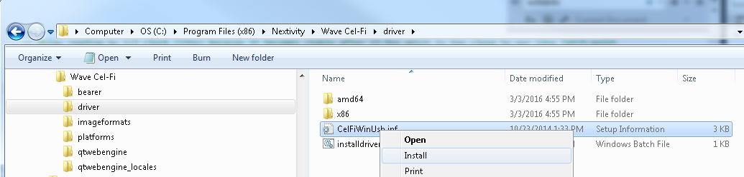

Windows 7 may complain that it cannot verify the publisher, like below

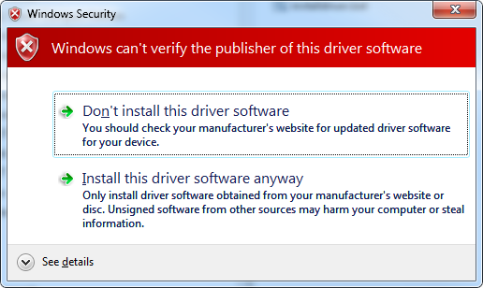

Click Install this driver software anyway and when done reconnect the Cel-Fi unit.